Design Thinking

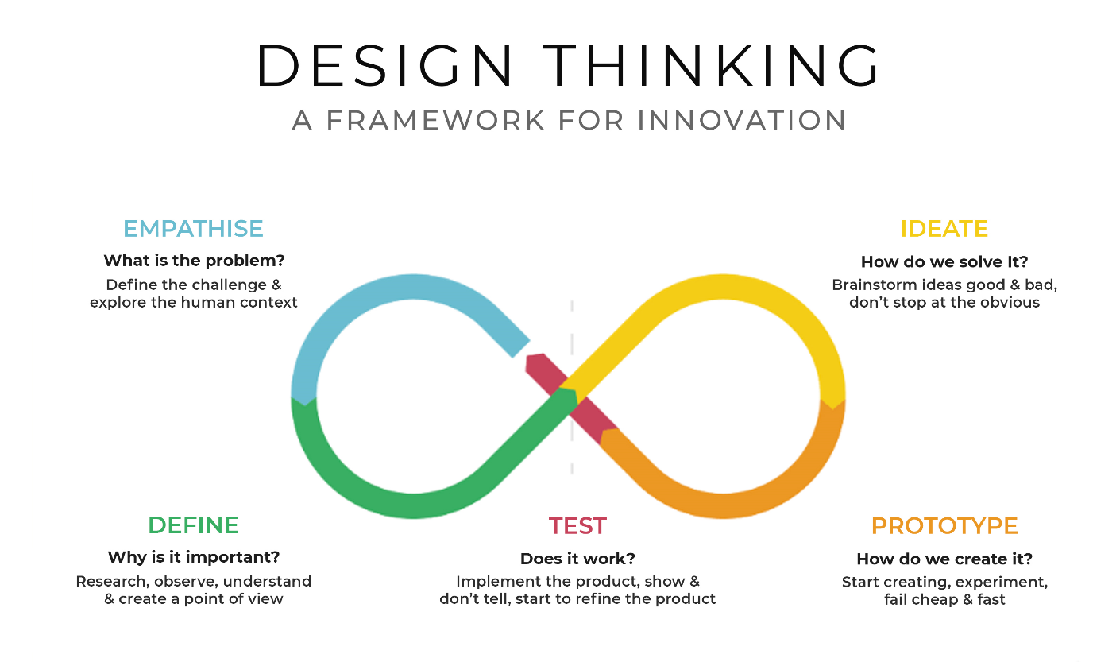

With the advent mobile application technological advancements, the design thinking principles has been increased and have a wide acceptance. Design thinking is in our Key. We believe that the finest products and experiences are built with design first. We work hard to blend beauty, form, and function to craft striking experiences. Our expert application developers employ design thinking principles and trending tools to develop user-friendly and easy-to-use mobile application